جامعة المنوفية
كلية الحاسبات والمعلومات
2026-2027
Menofyia University
System Analysis & design Project
second year
2026-2027


No. | Name | Section
1 | Mahmoud Elsaid Mahmoud Habbas | 3
2 | Ahmed Abdel Monem Ibrihem Abdel monem | 3
3 | Ahmed Fawzy Said Hegazy | 4
4 | Ahmed mohamed Abouzied | 5
5 | Eslam Mostafa elmasry | 7

Planning (Project Plan)

Project Identification
Project Name:
Question Bank management System
Current Problem:
1.Questions are stored manually in different files.
2. Finding specific questions takes a lot of time.
3. Duplicate or outdated questions may be used.
4. There is no centralized system to manage questions

Description about project:
The Question Bank Management System is a web-based system designed to help educational institutions, instructors, and administrators organize and manage exam questions. The system allows instructors to create and store different types of questions, such as MCQ, True/False, and Essay, and organize them by course, chapter, and difficulty level. It also allows users to search, edit, delete, and manage questions easily and securely.

System Request
System Request— Question Bank management System

Project Sponsor:
Business Need: | 1-Reduce the time spent managing questions.  2-Organize questions in one place.  3-Make questions easier to find and update.  4-Reduce duplicate or outdated questions.
Business Requirements: | 1-Allow instructors to add, edit, and delete questions.  2-Allow users to search and filter questions.  3-Categorize questions by course, topic, and difficulty level.  4-Store questions securely in a database
Business Value: | 1- Improve the exams preparation process.  2- Saving time.  3- Better organization of question.  4- Reducing manual work.
Special Issues or Constraints: | 1- Deadline in 1 January.  2- Constantly updating date.

Feasibility Analysis
Technical Feasibility
1. The system can be developed using HTML, CSS, JavaScript, and a database.
2. The system will provide a simple and user-friendly interface.
3. The system will allow users to add, edit, delete, search, and filter questions.
4. The system can be accessed through common web browsers.
Economic Feasibility
1. The development cost of the system will be low.
2. The system will reduce the time and effort needed to manage questions.
3. Free or low-cost development tools can be used.
4. The benefits of the system will outweigh its development costs.
Organizational Feasibility
1. Instructors and administrators can easily learn how to use the system.
2. The system will improve the organization and management of exam questions.
3. The system will reduce manual work for instructors.

Time Estimation

 | Planning | Analysis | Design | Implementation
Standard percentages | 15% | 20% | 35% | 30%
Estimated time based on planning time | Actual: 11 days | 16 days | 25 days | 22 days

Tasks Identification
System Request | Name of Task
2/10/2026 | Start Date
16/12/2026 | End Date
Ahmed Hegazy | Person assigned to task
High | Priority
Microsoft word | Resources Needed
4 hours | Estimated Time
2 hours | Actual Time

Feasibility Study | Name of Task
10/10/2026 | Start Date
15/10/2026 | End Date
Ahmed Mahmoud | Person assigned to task
High | Priority
Microsoft word | Resources Needed
2 hours | Estimated Time
3 hours | Actual Time

Pert Chart, Grantt Chart | Name of Task
17/10/2026 | Start Date
18/10/2026 | End Date
Ahmed Hegazy | Person assigned to task
High | Priority
Ms project | Resources Needed
2 hours | Estimated Time
2 hours | Actual Time

Interview | Name of Task
18/10/2026 | Start Date
………. | End Date
Mahmud | Person assigned to task
Medium | Priority
Microsoft word | Resources Needed
16 hours | Estimated Time
14 hours | Actual Time

Questionnaire | Name of Task
19/11/2020 | Start Date
23/11/2020 | End Date
Ahmed allam | Person assigned to task
medium | Priority
Form drive | Resources Needed
5 hours | Estimated Time
2 hours | Actual Time

Data Flow Diagram | Name of Task
24/11/2020 | Start Date
29/11/2020 | End Date
Ahmed Mahmoud, Ahmed allam | Person assigned to task
High | Priority
Internet | Resources Needed
1 day | Estimated Time
18 hours | Actual Time

Data Store | Name of Task
29/11/2020 | Start Date
2/12/2020 | End Date
Ahmed mahmoud | Person assigned to task
High | Priority
Microsoft word | Resources Needed
1 day | Estimated Time
17 hours | Actual Time

process specification | Name of Task
29/11/2020 | Start Date
3/12/2020 | End Date
Joulnar hussein | Person assigned to task
High | Priority
Microsoft word | Resources Needed
1 day and 10 hours | Estimated Time
19 hours | Actual Time

Entity Relationship | Name of Task
2/12/2020 | Start Date
6/12/2020 | End Date
rawan | Person assigned to task
High | Priority
StarUML | Resources Needed
1 day and 10 hours | Estimated Time
19 hours | Actual Time

Normalization | Name of Task
2/12/2020 | Start Date
6/12/2020 | End Date
ali raafat | Person assigned to task
High | Priority
StarUML | Resources Needed
1 day and 10 hours | Estimated Time
19 hours | Actual Time

design | Name of Task
7/12/2020 | Start Date
2/1/2021 | End Date
- | Person assigned to task
High | Priority
Visual studio code | Resources Needed
18 days | Estimated Time
13 days | Actual Time

Implementation | Name of Task
2/1/2021 | Start Date
24/1/2021 | End Date
Ahmed allam ,ali raafat | Person assigned to task
High | Priority
Visual studio code | Resources Needed
16 days | Estimated Time
11 days | Actual Time

Pert Chart (M S-Project)

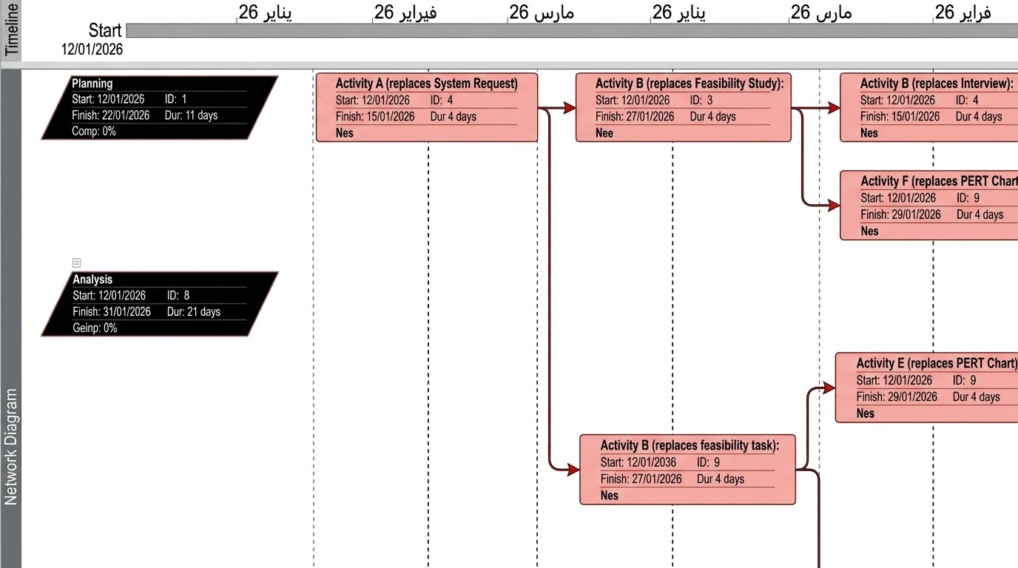
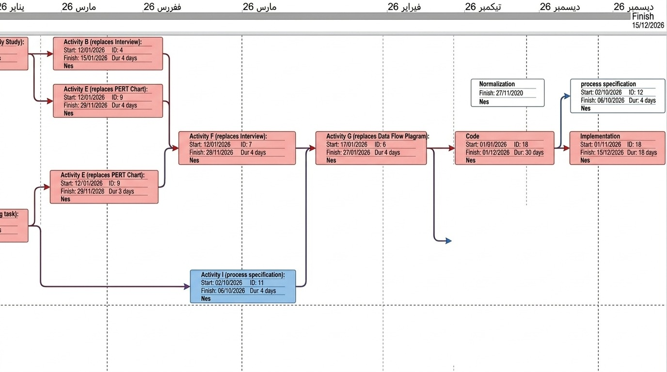

Gantt chart (MS-Project)

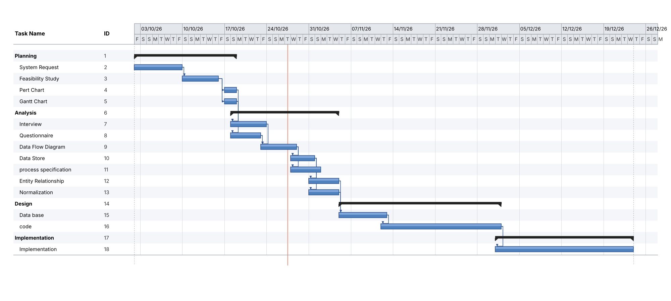

Analysis (Project Proposal)

Interview
(include questions and answers)
1- What's your opinion of the current method of managing questions?
The current method is not efficient because questions are stored in different files, making them difficult to organize, search, and update.
2- Is the current system easy to use?
No, managing questions manually takes time and effort, especially when dealing with a large number of questions.
3- How does the proposed Question Bank Management System work?
The system provides a centralized database where users can add, store, update, delete, search, and organize questions. Questions can be categorized by subject, topic, difficulty level, and question type, making them easier to find and manage.
4- What are the common problems with the current method?
- Duplicate questions.
- Difficulty finding specific questions.
- Disorganized files.
- Loss of information or incorrect updates.
- Time-consuming manual work.
5- What are the critical objectives of your system?
- Organize and manage questions efficiently.
- Ease of use.
- Save time and effort.
- Store a large number of questions in one place.
- Search and categorize questions easily.
6- What technologies do you use now in your current system?
- Microsoft Word and Excel to store and organize questions.
- Manual methods to manage and update questions.
- Limited security and difficulty managing large numbers of questions.
7- What technologies do you want to add to the new system?
- Create a user-friendly interface for managing questions.
- Use a database to store and organize questions.
- Add search and filtering features.
- Allow users to add, edit, and delete questions.
- Support different question types, such as multiple-choice and true-or-false questions.
8- If the user finds a problem, can your system help them?
Yes, the system will help users find and manage questions easily, but it may not solve technical problems outside its functionality.
9- Do you have anything else to add?
No, thank you.

Interview Reports
Interview Report
Person Interviewed: Mr. Ahmed
Interviewer: Ahmed Allam
Purpose of Interview:
- To understand the current method of managing educational questions.
- To identify problems with storing, searching, and organizing questions.
- To determine the required features and improvements for the new system.
Summary of Interview:
- The current method of managing questions takes time and effort.
- Common problems include duplicate questions, difficulty finding specific questions, and disorganized files.
- The proposed system will provide a centralized database to store, search, update, and organize questions.
- The system aims to improve efficiency, save time, and reduce manual errors.
Open Items:
- 1- Design a user-friendly interface for managing questions.
- 2- Create a database to store and organize questions efficiently.
- 3- Add search and filtering features based on subject, topic, and difficulty level.
- 4- Support adding, editing, and deleting questions.
- 5- Support different question types, such as multiple-choice and true-or-false questions.
Detailed Notes: See attached interview questions and answers.

Interview Report
Person Interviewed: Mr. Ali
Interviewer: Ahmed
Purpose of Interview:
- To understand the current system workflow.
- To analyze system advantages and address existing errors.
- To identify necessary system tools and outline future development plans.
Summary of Interview:
- The proposed system is a website designed for easy book retrieval. Users can find books quickly by entering a specific code or the book's title. The system also enables users to borrow books.
- The system will support the process of accessing and uploading a large volume of books to the website.
- A user registration page will be created on the website to manage user access.
- A page will be developed to add a selection of non-free (paid) books to the catalog.
Open Items:
- 1- A requirement for a minimum of 6 employees within one operational section.
- 2- Creation of a mobile application to streamline and accelerate the purchase process for customers.
- 3- Development of a website page to provide a user-friendly online buying experience.
Detailed Notes: See attached transcript.

Interview Report
Person Interviewed: Eng. Mohamed
Interviewer: Ahmed
Purpose of Interview:
- To understand how the system operates.
- To utilize system advantages and address current errors.
- To identify core system tools and outline how they will be developed.
Summary of Interview:
- The system is a comprehensive website library that contains various types of books across different fields.
- A primary concern identified is preventing the loss of authors' copyrights.
- The system needs to integrate and support multiple payment methods for users.
Open Items:
- 1- Establishing strict digital rights management (DRM) policies to protect book content and authors' copyrights.
- 2- Integrating secure third-party payment gateways to allow seamless online transactions.
- 3- Developing an intuitive web interface for browsing, searching, and managing book categories.
Open Items:
- 1- Minimum 6 employees in one section.
- 2- Create an application mobile to make the purchase process fast for the customer.
- 3- Create a website page to make buying online easy to the user.
Detailed Notes: See attached transcript.

Questionnaire & RESPONSES
(using Google Forms, you must includ e questions and statistics) 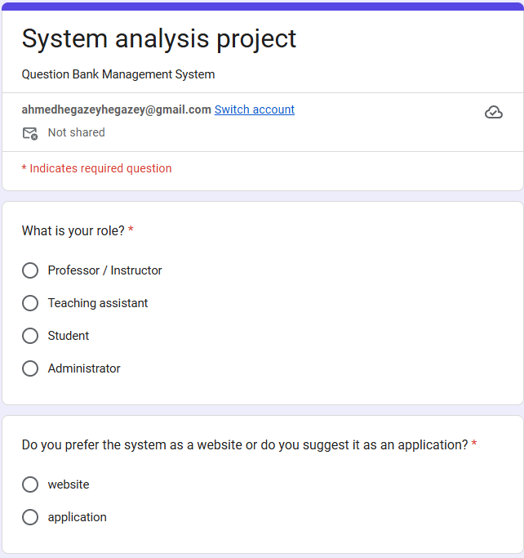
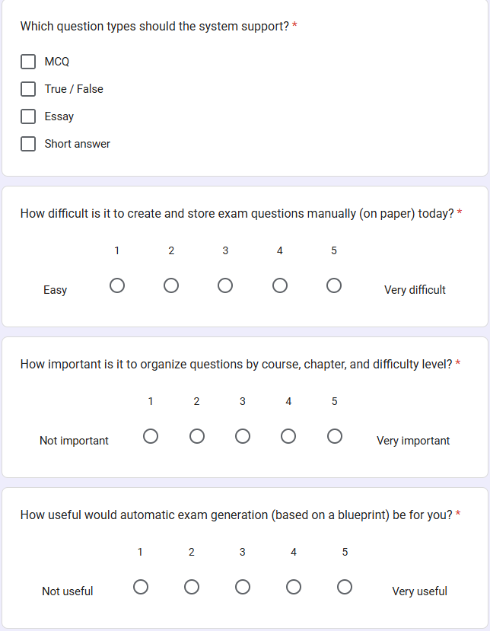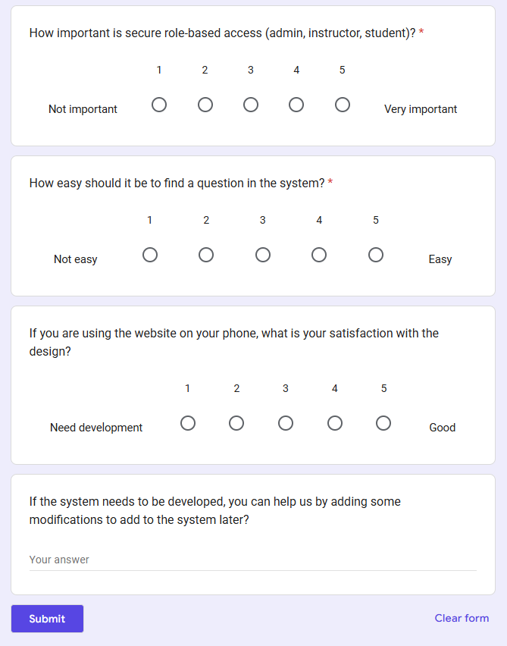

Data Flow Diagram - Context Diagram

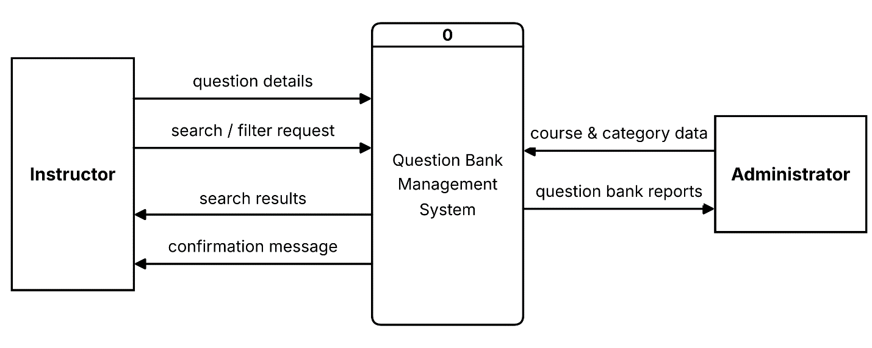

Data Flow Diagram – Level/Diagram 0
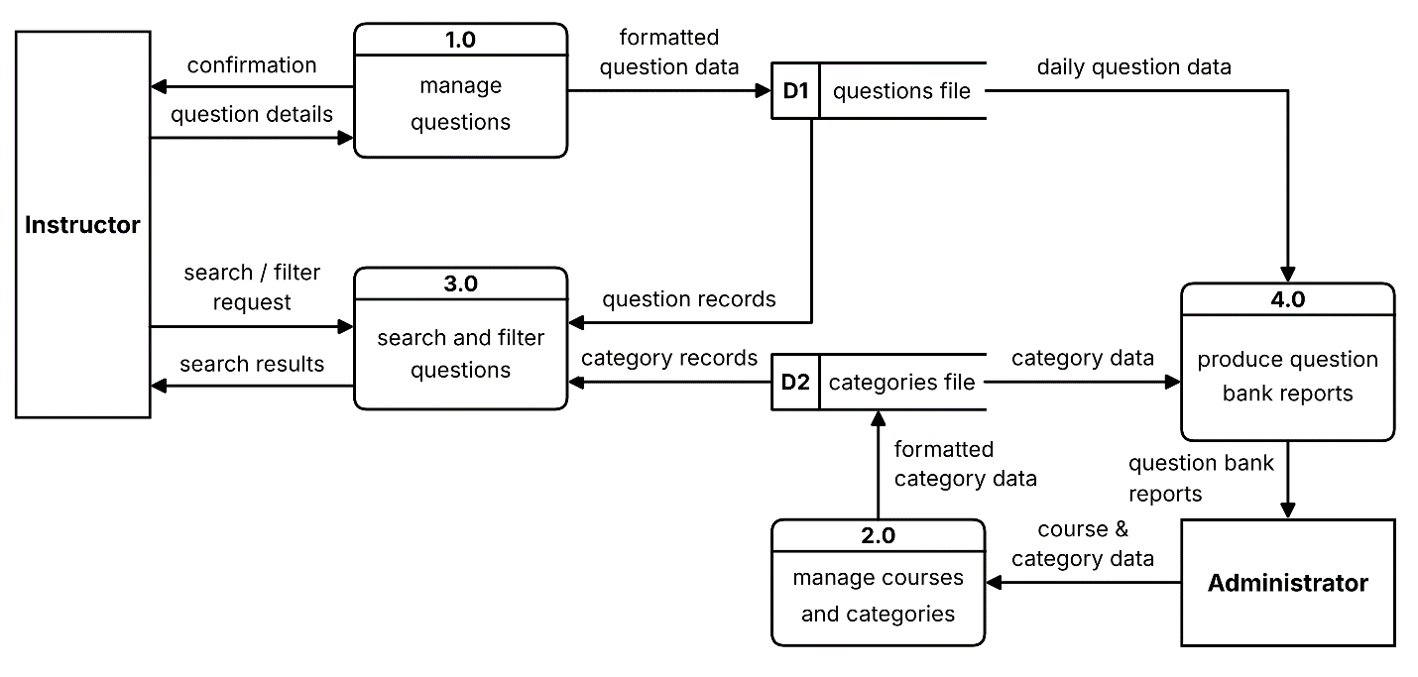

Data Flow Diagram – Level 1

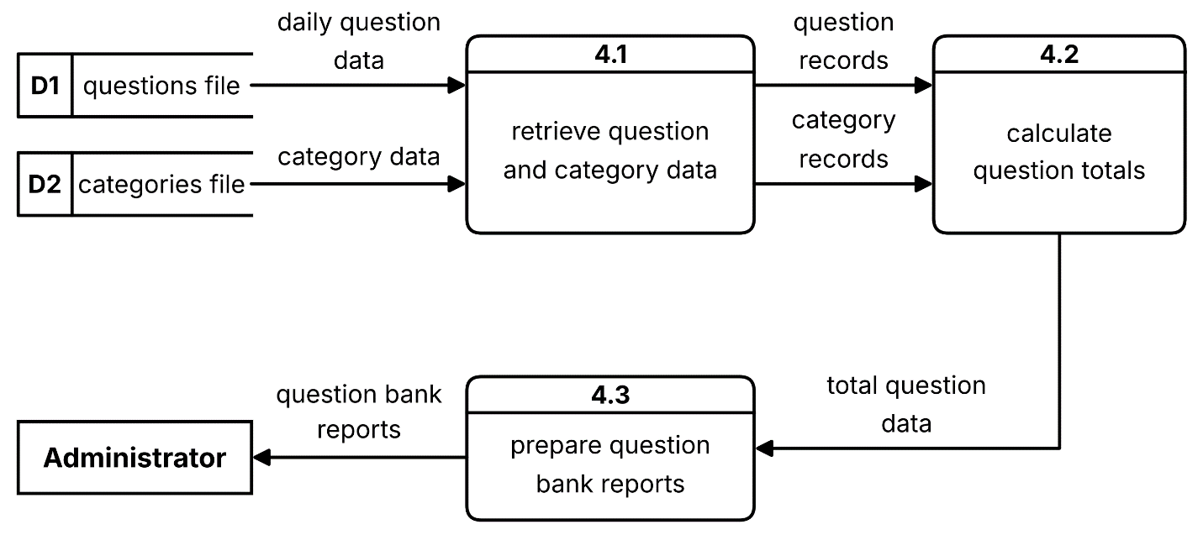
Data Dictionary
DFD: Data Flow
- Description form for Data Flow
Data Flow Description Form
ID: 1
Name (label): user order
Description: contains the customer’s order
Source  External entity - User | Destination  Process 1.0 - receive and transform online book order
Type of Data Flow

File Screen Report Form Internal
Data structure  User data |  | Volume/time  2/hour
comments:

it contains the order of the customer about what the online book he need

Data Flow Description Form
ID: 2
Name (label): receipt
Description: contains the receiving data
Source  Process 1.0 - receive and transform online book order | Destination  External entity - User
Type of Data Flow

File Screen Report Form Internal
Data structure  Receipt data |  | Volume/time  4/hour
comments:

It contains the receiving data mean that the book orders which the customer request from the online library. It will appear a message which says if this book is existing or not.

Data Flow Description Form
ID: 3
Name (label): Book Order
Description: contains the transforming data
Source  Process 1.0 - receive and transform online book order | Destination  External entity – online library
Type of Data Flow

File Screen Report Form Internal
Data structure  Transformation data |  | Volume/time  3/hour
comments:

it contains the transformation data about the book order after receiving it from the user

Data Flow Description Form
ID: 4
Name (label): online books sold
Description: contains the sold information data
Source  Process 1.0 - receive and transform online book order | Destination  Process 2.0 – update online books sold file
Type of Data Flow

File Screen Report Form Internal
Data structure  Sold data |  | Volume/time  8/hour
comments:

it contains the information of the sold books like how many and what the amount, etc.

Data Flow Description Form
ID: 5
Name (label): inventory data
Description: contains information about the inventory
Source  Process 1.0 - receive and transform online book order | Destination  Process 3.0 – update inventory file
Type of Data Flow

File Screen Report Form Internal
Data structure  Inventory data |  | Volume/time  10/hour
comments:

It contains the information about the inventory of the books because it needs to be updated every once the customer buy a book.

Data Flow Description Form
ID: 6
Name (label): formatted online books sold data
Description: contains the formatted sold information
Source  Process 2.0 – update online books sold file | Destination  Data store – online books sold file
Type of Data Flow

File Screen Report Form Internal
Data structure  Formatted sold data |  | Volume/time  9/hour
comments:

it contains the information data about the sold online books after being formatted

Data Flow Description Form
ID: 7
Name (label): formatted inventory data
Description: contains the formatted inventory information
Source  Process 3.0 – update inventory file | Destination  Data store – inventory file
Type of Data Flow

File Screen Report Form Internal
Data structure  Formatted inventory data |  | Volume/time  9/hour
comments:

it contains the formatted information data about the inventory

Data Flow Description Form
ID: 8
Name (label): daily online sold books amount
Description: it contains the daily sold amount
Source  Data store – online books sold file | Destination  Process 4.0 – produce operation reports
Type of Data Flow

File Screen Report Form Internal
Data structure  Sold amount data |  | Volume/time  4/hour
comments:

contains the online sold books amount report which been sold the whole day

Data Flow Description Form
ID: 9
Name (label): daily inventory depletion amount
Description: contains the daily inventory amount
Source  Data store – inventory file | Destination  Process 4.0 – produce operation reports
Type of Data Flow

File Screen Report Form Internal
Data structure  Inventory amount data |  | Volume/time  4/hour
comments:

it contains the information about the daily inventory amount data (the store)

Data Flow Description Form
ID: 10
Name (label): operation reports
Description: contains the final report
Source  Process 4.0 – produce operation reports | Destination  External entity –website manager
Type of Data Flow

File Screen Report Form Internal
Data structure  Report data |  | Volume/time  2/hour
comments:

It contains the final report data after the system of the online books library work the whole day. It will go to the website manager at the end

(2)Data Structure for Data Flow
User = first name + last name + password + phone number + user address + email + credit card number + security code
Receipt = first name + last name + phone number + user address + email + book name
Book order = book name + first name + last name + password + phone number + user address + email + credit card number + security code
Online books sold = book name + sold amount + [profits, losses] + first name + last name + book code + book ID
Inventory data = book name + inventory amount + book code + book ID
Formatted online books sold data = book name + book ID + book code + sold amount + [profits, losses] + first name + last name
Formatted inventory data = book name + inventory amount + book code + book ID
Daily online books sold amount = book name + book ID + book code + sold amount + [profits, losses] + first name + last name + user address + email + (date)
Daily inventory depletion amount = book name + inventory amount + book code + book ID + (date)
Operation reports = first name + last name + phone number + user address + email + book name + sold amount + [profits, losses] + book code + book ID + inventory amount + (date)

- Data Structure for Data Flow: Structural Record
User = first name + last name + password + phone number + user address + email + credit card number + security code
Receipt = first name + last name + phone number + user address + email + book name
Book order = book name + first name + last name + password + phone number + user address + email + credit card number + security code
Online books sold = book name + sold amount + [profits, losses] + first name + last name + book code + book ID
Inventory data = book name + inventory amount + book code + book ID
Formatted online books sold data = book name + book ID + book code + sold amount + [profits, losses] + first name + last name
Formatted inventory data = book name + inventory amount + book code + book ID
Daily online books sold amount = book name + book ID + book code + sold amount + [profits, losses] + first name + last name + user address + email + (date)
Daily inventory depletion amount = book name + inventory amount + book code + book ID + (date)
Operation reports = first name + last name + phone number + user address + email + book name + sold amount + [profits, losses] + book code + book ID + inventory amount + (date)
- Data Element for data flow
 | ID
First name | Name
Customer first name | Alias
Contains the customer`s first name | Description
20 | Length
X(20) | Input Format
X(20) | Output Format
 | Default Value
Discrete | Continuous / Discrete
Alphabetic | Type
Base | Base / Derived
 | Upper Limit
 | Lower Limit
 | Discrete
Every customer has a first name | Comments

 | ID
Second name | Name
Customer second name | Alias
Contains the customer`s second name | Description
20 | Length
X(20) | Input Format
X(20) | Output Format
 | Default Value
Discrete | Continuous / Discrete
Alphabetic | Type
Base | Base / Derived
 | Upper Limit
 | Lower Limit
 | Discrete
Every customer has a second name | Comments

 | ID
Password | Name
Customer password | Alias
Contains the customer`s password | Description
10 | Length
9(10) | Input Format
9(10) | Output Format
 | Default Value
Continuous | Continuous / Discrete
Number | Type
Derived | Base / Derived
 | Upper Limit
 | Lower Limit
 | Discrete
Every customer should has a password | Comments

 | ID
Phone number | Name
Customer phone number | Alias
Contains the customer`s phone number | Description
15 | Length
9(15) | Input Format
9(15) | Output Format
 | Default Value
Continuous | Continuous / Discrete
Number | Type
Derived | Base / Derived
 | Upper Limit
 | Lower Limit
 | Discrete
Every customer should have a phone number | Comments

 | ID
User address | Name
Customer address | Alias
Contains the customer`s address | Description
30 | Length
X(30) | Input Format
X(30) | Output Format
 | Default Value
Discrete | Continuous / Discrete
Alphabet | Type
Base | Base / Derived
 | Upper Limit
 | Lower Limit
 | Discrete
Every customer should have an address | Comments

 | ID
Email | Name
Customer email | Alias
Contains the customer`s email | Description
40 | Length
X(40) | Input Format
X(40) | Output Format
 | Default Value
Discrete | Continuous / Discrete
Alphabet | Type
Base | Base / Derived
 | Upper Limit
 | Lower Limit
 | Discrete
Every customer should have address | Comments

 | ID
Credit card number | Name
Customer credit card | Alias
Contains the customer`s credit card number or code | Description
20 | Length
9(20) | Input Format
9(20) | Output Format
 | Default Value
Continuous | Continuous / Discrete
Number | Type
Derived | Base / Derived
 | Upper Limit
 | Lower Limit
 | Discrete
Every customer should have a credit card | Comments

 | ID
Security code | Name
Customer security code | Alias
Contains the customer`s security code | Description
30 | Length
9(30) | Input Format
9(30) | Output Format
 | Default Value
Continuous | Continuous / Discrete
Number | Type
Derived | Base / Derived
 | Upper Limit
 | Lower Limit
 | Discrete
Every customer should have a security code to keep his information safe | Comments

 | ID
Book name | Name
Book`s name | Alias
Contains the book`s name | Description
25 | Length
X(25) | Input Format
X(25) | Output Format
 | Default Value
Discrete | Continuous / Discrete
Alphabet | Type
Base | Base / Derived
 | Upper Limit
 | Lower Limit
 | Discrete
Every book should have a name | Comments

 | ID
Sold amount | Name
Number of sold amount | Alias
Contains the number of the sold amount | Description
10 | Length
9(10) | Input Format
9(10) | Output Format
 | Default Value
Continuous | Continuous / Discrete
Number | Type
Derived | Base / Derived
 | Upper Limit
 | Lower Limit
 | Discrete
The sold amount is important to know daily | Comments

 | ID
[profits, losses] | Name
Profits or losses | Alias
Contains the number of the profits or the losses | Description
10 | Length
9(10) | Input Format
9(10) | Output Format
 | Default Value
Continuous | Continuous / Discrete
Number | Type
Derived | Base / Derived
 | Upper Limit
 | Lower Limit
 | Discrete
We should always know the number of the profits or the losses | Comments

 | ID
Book code | Name
Book code | Alias
Contains the book`s code | Description
20 | Length
9(20) | Input Format
9(20) | Output Format
 | Default Value
Continuous | Continuous / Discrete
Number | Type
Derived | Base / Derived
 | Upper Limit
 | Lower Limit
 | Discrete
The book should have a code | Comments

 | ID
Book ID | Name
Book ID | Alias
Contains the book`s ID | Description
20 | Length
9(20) | Input Format
9(20) | Output Format
 | Default Value
Continuous | Continuous / Discrete
Number | Type
Derived | Base / Derived
 | Upper Limit
 | Lower Limit
 | Discrete
The book should has an ID | Comments

 | ID
Inventory amount | Name
Inventory amount | Alias
Contains the inventory`s amount | Description
15 | Length
9(15) | Input Format
9(15) | Output Format
 | Default Value
Continuous | Continuous / Discrete
Number | Type
Derived | Base / Derived
 | Upper Limit
 | Lower Limit
 | Discrete
Every day the inventory will be updated | Comments

 | ID
(date) | Name
Date | Alias
Contains the operation`s date | Description
20 | Length
9(20) | Input Format
9(20) | Output Format
 | Default Value
Continuous | Continuous / Discrete
Number | Type
Derived | Base / Derived
 | Upper Limit
 | Lower Limit
 | Discrete
The date of every operation is an optional element | Comments

DFD: Data Store
 | ID
Online books sold file | Name
Sold file | Alias
Contains the sold file | Description
Database | File Type
 | File Format
20 | Record Size
40 | Maximum Records
30 | Average Records
4/year | Growth per Year
 | Data Set
Store data | Data Structure
 | Primary Key
 | Secondary Key
The sold amount should be stored daily | Comments

 | ID
Inventory file | Name
Inventory file | Alias
Contains the inventory file | Description
Database | File Type
 | File Format
20 | Record Size
40 | Maximum Records
30 | Average Records
4/year | Growth per Year
 | Data Set
Store data | Data Structure
 | Primary Key
 | Secondary Key
The inventory amount are being updated daily so that it should be stored daily | Comments

Process Specification
- Note: apply process specification for all project processes

Process Specification Form
Number: 1.o
Name: Receive and transform order
Description: This process use to receive and transform the user order
Input Data Flow
The user order from External Entity
Output Data Flow
Send the order to the online library and receipt the order
Type of Process
Online Batch Manual
Process Logic:
IF customer is preferred customer then
If Customer order more than 1000$ then
Apply a 5% discount
If Customer use char card
Apply an additional 5% discount then
End if
Award 25$ bonus coupon
End if
Else Award 5$ bonus coupon
End if
Structured English Decision Table Decision Tree
Unresolved Issues:
Process Specification Form
Number: 2.o
Name: update online books sold file
Description: this process receive the update of online Sold Books and store the update in the online books Sold file
Input Data Flow :
the online sold books
Output Data Flow
Formatted online books sold file
Type of Process
Online Batch Manual
Process Logic:
 |  | 1 | 2 | 3 | 4 | 5 | 6 | 7 | 8
1 | Lack of books | Y | Y | Y | Y | N | N | N | N
2 | New book release | Y | Y | N | N | Y | Y | N | N
3 | Laggy server | Y | N | Y | N | Y | N | Y | N

1 | New update | X | X | X | X
2 | Add the new version | X | X |  |  | X | X
3 | New features | X |  | X |  | X |  | X
4 | Weekly update |  |  |  |  |  |  |  | X

Structured English Decision Table Decision Tree
Unresolved Issues:

Process Specification Form
Number: 3.o
Name: update inventory file
Description: this process receive the inventory data ,update it and formatted it into inventory file
Input Data Flow : inventory data
inventory data
Output Data Flow :
Formatted inventory data
Type of Process
Online Batch Manual
Process Logic:

 |  | 1 | 2 | 3 | 4 | 5 | 6 | 7 | 8
1 | Lack of quantity | Y | Y | Y | Y | N | N | N | N
2 | The order is greater than quantity | Y | Y | N | N | Y | Y | N | N
3 | The quantity is not knowing | Y | N | Y | N | Y | N | Y | N

1 | Update a new stock | X | X | X | X
2 | Move order to backordered record | X | X |  |  | X | X
3 | Do quantity inventory | X |  | X |  | X |  | X
4 | Weekly inventory |  |  |  |  |  |  |  | X

Structured English Decision Table Decision Tree
Unresolved Issues:

Process Specification Form
Number: 4.o
Name: produce operation reports
Description: this process receive the daily inventory depletion amounts and the daily online sold books amounts and do operation report and send it to the website manager
Input Data Flow :
daily online sold books amounts and inventory depletion amounts
Output Data Flow
The operation report
Type of Process
Online Batch Manual
Process Logic:

Routine update
2

Lack of books
Call the it unit to fix the error
3

Errors in the system
1
New features
4
Laggy server

Preferred customer Do discount
5

Structured English Decision Table Decision Tree
Unresolved Issues:

Normalization
Normal Tables
id | Name | email | Book id | price | Payment type | Publisher id | Publisher name | address
1 | ahmed | Ah12@gmail.com | 3 | 16$ | visa | 2 | Hassan | Cairo
2 | ali | Al12@gmail.com | 3 | 16$ | visa | 3 | Osama | Giza
3 | rawan | ra12@gmail.com | 4 | 20$ | visa | 1 | Mohamed | Aswan
1 | ahmed | Ah12@gmail.com | 4 | 10$ | cash | 3 | Osama | Giza
3 | rawan | ra12@gmail.com | 2 | 10$ | cash | 2 | Hassan | Cairo
4 | joulnar | jo18@gmail.com | 4 | 20$ | visa | 4 | Jone | USA
2 | ali | Al12@gmail.com | 3 | 16$ | visa | 1 | Mohamed | Aswan

Tables after 1NF
id | Name | email
1 | ahmed | Ah12@gmail.com
2 | Ali | Al12@gmail.com
3 | Rawan | ra12@gmail.com
4 | joulnar | jo18@gmail.com

id | Book id | price | Payment type | Publisher id | Publisher name | address
1 | 3 | 16$ | visa | 2 | Hassan | Cairo
2 | 3 | 16$ | visa | 3 | Osama | Giza
3 | 4 | 20$ | visa | 1 | Mohamed | Aswan
1 | 4 | 10$ | cash | 3 | Osama | Giza
3 | 2 | 10$ | cash | 2 | Hassan | Cairo
4 | 4 | 20$ | visa | 4 | Jone | USA
2 | 3 | 16$ | visa | 1 | Mohamed | Aswan

Tables after 2NF
id | Name | email
1 | ahmed | Ah12@gmail.com
2 | Ali | Al12@gmail.com
3 | Rawan | ra12@gmail.com
4 | joulnar | jo18@gmail.com

Publisher id | Publisher name | address
2 | Hassan | Cairo
3 | Osama | Giza
1 | Mohamed | Aswan
4 | Jone | USA

id | Publisher id | Book id | price | Payment type
1 | 2 | 3 | 16$ | visa
2 | 3 | 3 | 16$ | visa
3 | 1 | 4 | 20$ | visa
1 | 3 | 4 | 10$ | cash
3 | 2 | 2 | 10$ | cash
4 | 4 | 4 | 20$ | visa
2 | 1 | 3 | 16$ | visa

Tables after 3NF
id | Name | email
1 | ahmed | Ah12@gmail.com
2 | Ali | Al12@gmail.com
3 | Rawan | ra12@gmail.com
4 | joulnar | jo18@gmail.com

Publisher id | Publisher name | address
2 | Hassan | Cairo
3 | Osama | Giza
1 | Mohamed | Aswan
4 | Jone | USA

id | Publisher id | Book id | price | Payment type
1 | 2 | 3 | 16$ | visa
2 | 3 | 3 | 16$ | visa
3 | 1 | 4 | 20$ | visa
1 | 3 | 4 | 10$ | cash
3 | 2 | 2 | 10$ | cash
4 | 4 | 4 | 20$ | visa
2 | 1 | 3 | 16$ | visa

Entity Relationship Diagram (ERD)

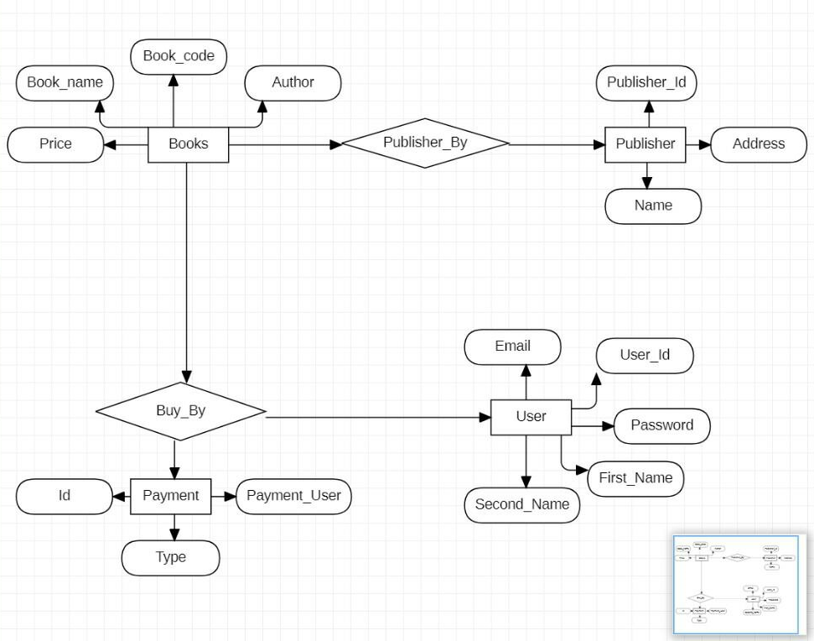
UML – Use Case
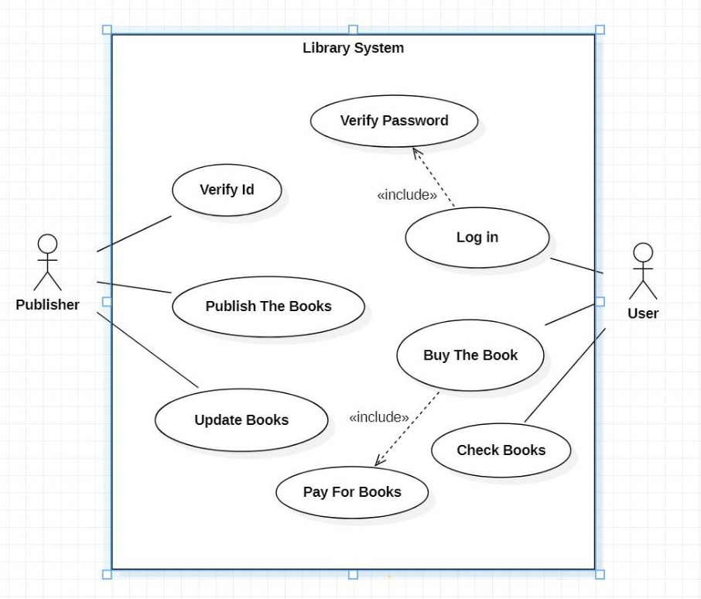
UML – Class Diagram
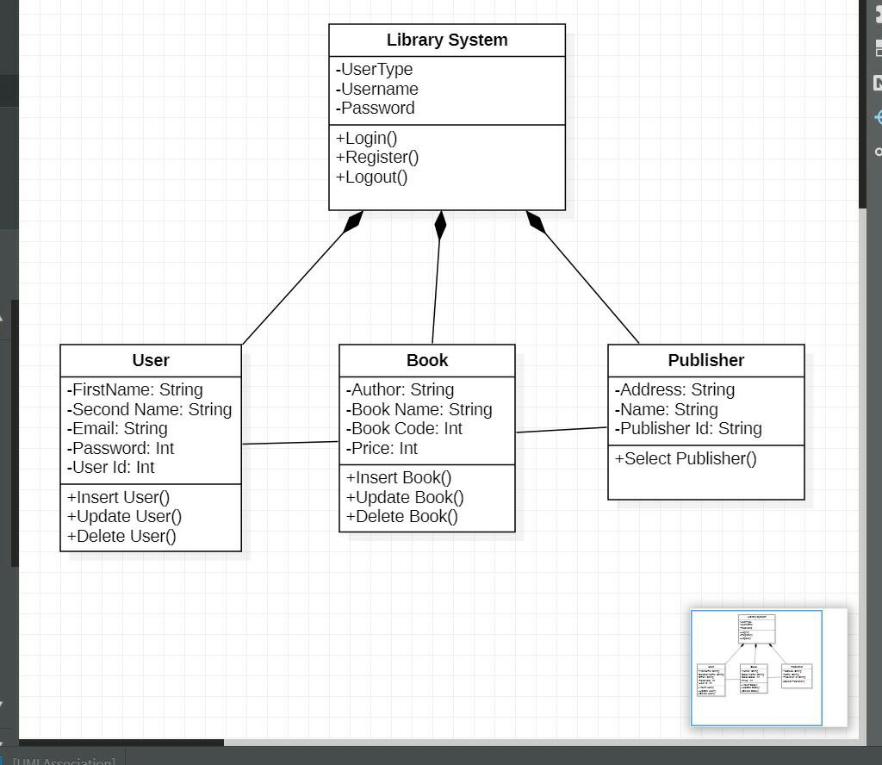
UML – Sequence Diagram
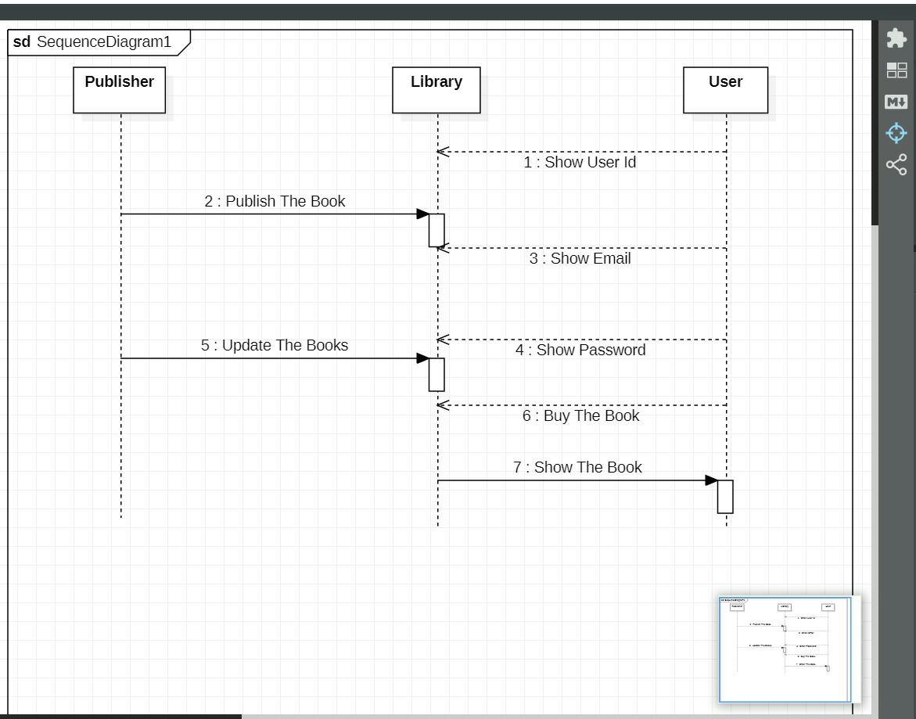

Design (Project Specification)
[A] Architecture Design
    - Operational Requirements
Requirement
Technical Environment
System Integration
Portability
Maintainability

2. Performance Requirements
Requirement
Speed
Capacity
Availability and reliability

3. Security Requirements
Requirement
System value estimates
Access control
Encryption and authentication
Virus control

[2] Data storage Design

1. Data storage format:

2. Convert logical ERD to physical ERD:

[3] Program design
- Convert logical DFD to physical DFD:

[4] Interface design
1. Use Scenario Development

2. Interface Structure Design

3. Interface Standards Design
(1) Interface Metaphor

(2) Interface Template

4. Interface Design Prototyping
Implementation (New System)

